The Spike Protein and Cobra Venom
By Craig Paardekooper (28th June 2021)

The Spike protein is manufactured by your cells in response to the COVID-19 vaccine. However, this Spike protein is not biologically inactive; rather it has a strong affinity for at least 2 important receptors found on cell membranes – the ACE2 receptor, and the nicotinic Acetylcholine receptor (nAChr) . When it binds to these receptors it disrupts normal signalling – leading to –
- Blood clotting, when it binds to ACE2
- Disruption of neuronal signalling, when it binds to nAChr.
In this article, I am focusing on the effect of the Spike on the latter.

Where are Nicotinic Acetylcholine Receptors Found?
- At the Junction Between Neuron and Muscle :
They are mainly located at neuro-muscular junctions, i.e. between motor nerve and skeletal muscle.
- In the Sympathetic and Parasympathetic Autonomic Nervous System
The nACh receptors are located on the ganglion at the junction with the preganglionic nerve – which is the nerve between the spine and the ganglion
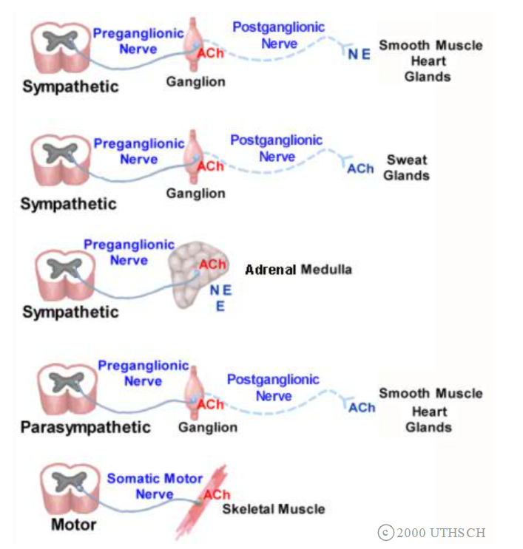
- In the Central Nervous System
The nACh receptors are found –
  - Between neurons
  - The pathway from the basal forebrain to the forebrain neocortex
  - Most sub cortical areas, which are innervated by thousands of nerves from the ponto-mesencephalic region
  - The pathway from the medial septal and diagonal band region to limbic structures
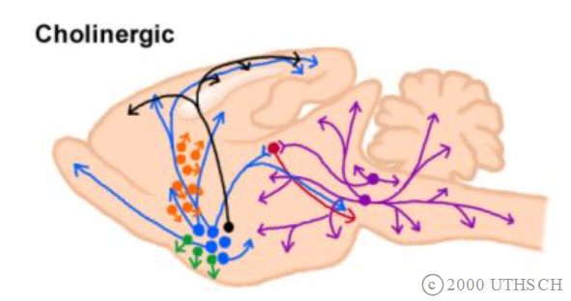
What Are The Effects of Disruption to these Pathways?
Acetylcholine is an essential neurotransmitter for transmission of nerve signals between neurons and muscles.
By binding to acetylcholine receptors, the spike disrupts this transmission – leading to symptoms such as tremors, seizures, spasms, loss of motor control.
Disruption of the sympathetic and parasympathetic systems will result in dysregulation of the heart muscle
Disruption of the central nervous system pathway from the basal forebrain to the forebrain neocortex will result in Alzheimers.
Disruption of the central nervous system inter-neuronal signalling will result in cognitive and affective disruption

What is the Current Extent of the Disruption - How Many Cases?
For Pfizer alone, there are currently recorded 555,214 cases of neurological disorder following vaccination – including – tremor (22,502 cases), seizure (4985 cases)
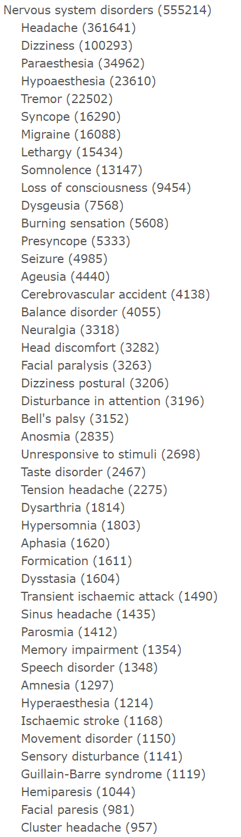

The Function of Acetylcholine
Acetylcholine receptors occur throughout the body. One of their main functions is the transmission of nerve signals to muscles. Every muscle movement in your body is dependent upon a nerve signal being passed on to a muscle by an acetylcholine receptor.
In order to pass a signal from a nerve to a muscle cell, the nerve secretes acetylcholine, which diffuses across to the muscle cell and binds to the acetylcholine receptor on the muscle cell. When it binds to the receptor it triggers a muscle contraction in the muscle cell – hence movement.
The receptor that acetylcholine binds to on the muscle is called a “nicotinic acetylcholine receptor”. The nicotinic receptor is an ion channel – which means that it is like a pore that can be opened or closed to allow charged atoms to pass through. When acetylcholine binds to the receptor, the pore opens, allowing movement of Na+ ions into the muscle cell, resulting in muscle contraction.
Once it has produced a nerve impulse, the acetylcholine is then broken down by acetylcholinesterase.
If too much acetylcholine is produced, or if acetylcholinesterase fails to break it down, then persistent contractions of the muscles will result. Hence tremors.
It is also true that if another substance can mimic acetylcholine without being broken down by acetylcholinesterase, then that substance would also produce tremors.
Some Background on the Acetylcholine Receptor
The acetylcholine receptor is composed of five alpha helical chains each with about 370 amino acids. This is a transmembrane protein forming a funnel into the cytosol of the cell.
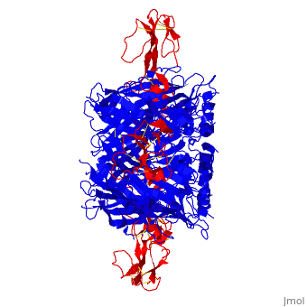
When a nerve cell is stimulated, the neurotransmitter acetylcholine is released from it and diffuses across the short space between the neuron and the muscle. When it reaches the muscle surface, it binds to a special receptor called an acetylcholine receptor. When acetylcholine binds to the receptor, it changes the shape of the receptor- making the central pore larger to allow the passage of charged atoms (ions) into the muscle cell. As a result Na⁺ ions flow into the muscle cell, increasing its positive charge, and this results in a contraction of the muscle, and movement results. If this process is disrupted, then movement will be chaotic and involuntary.

The Spike Protein has a Strong Affinity for Acetylcholine Receptors
The paper below shows that the Spike protein has an affinity for the nicotinic acetylcholine receptors found on skeletal muscle.
https://www.ncbi.nlm.nih.gov/pmc/articles/PMC7386492/?fbclid=IwAR1hBpmf2xq6Ya9d71KBjoWMlUxfvCG-6Veu2WIdi0UjO3a0FZjbB4tMLsg
This affinity will result in two possible outcomes - either the Spike will act as an antagonist - reducing voluntary muscle contractions - or it will act as an agonist - resulting in tremors.
Another study confirms that the Spike protein has strong affinity for acetylcholine receptors.
https://www.sciencedirect.com/science/article/pii/S2214750020304583

Comparison with Cobra Toxin
Cobra venom also binds to the acetylcholine receptor - so the spike acts just like cobra venom. When cobra venom is introduced into the body is moves along the bloodstream until it finds the acetylcholine receptots on a muscle cell – in this case a diaphragm muscle. The Cobra toxin binds to the acetylcholine receptor on the diaphragm muscle cell ,by interacting with OH group, and forces the acetyl choline channel to stay open As a consequence, the diaphragm muscle is permanently contracted so an individual cannot take a breath. Five molecules of cobra toxin (red) are necessary to block an acetylcholine receptor (blue) as each molecule binds with an individual alpha chain on the acetylcholine receptor.

Comparison with Nerve Agents
When a normally functioning motor nerve is stimulated, it releases the neurotransmitter acetylcholine, which transmits the impulse to a muscle or organ. Once the impulse is sent, the enzyme acetylcholinesterase immediately breaks down the acetylcholine in order to allow the muscle or organ to relax.
Nerve agents disrupt the nervous system by inhibiting the function of the enzyme acetylcholinesterase by forming a covalent bond with its active site, where acetylcholine would normally be broken down (undergo hydrolysis). Acetylcholine thus builds up and continues to act so that any nerve impulses are continually transmitted and muscle contractions do not stop. This same action also occurs at the gland and organ levels, resulting in uncontrolled drooling, tearing of the eyes (lacrimation) and excess production of mucus from the nose (rhinorrhea).
Whilst the mechanism of action of the Spike protein with Ach receptors differs from that of nerve agents, nerve agents provide a visual idea of the effects of disrupting the acetylcholine pathway.

Anti-Venom
There are only two ways to save a life after being infected with cobra venom the first being an artificial respirator to contract and expand the lungs until the diaphragm is able to start an action potential and contract on its own. The other option to a quick administration of an anti-venom. Anti-venom acts to bind the venom both in the receptor and in the bloodstream and allows for it to be excreted out of the body.
If the Spike blocks the acetylcholine receptors we can expect it to create similar effects to cobra venom. The Anti-venom is anything that is able to bind to the venom both in the receptor and in the bloodstream, and which allows for it to be excreted out of the body.
https://proteopedia.org/wiki/index.php/Acetylcholine_Receptor_and_its_Reaction_to_Cobra_Venom
Anti-venoms include -
1. Ivermectin
This drug binds to the Spike and blocks its action. You have probably heard that Ivermectin has been used against Covid 19 virus with some success. Its mode of action with C 19 was to bind to the Spike of the virus. So it stands to reason that Ivermectin will block the effects of the Spike when the Spike is on its own, since Ivermectin will still bind to it.
https://pubmed.ncbi.nlm.nih.gov/32871846/
2. Suramin
This drug is found in pine needles. It is extracted from the pine needles as a tea by stewing the pine needles in boiling water.
https://www.biorxiv.org/content/10.1101/2020.08.28.270306v1
3. Nicotine
Other substances that can act as nicotinic agonists (as described in the second paper above)
Nicotine is one such substance, which can be administered using a nicotine patch to avoid the other harmful chemicals found in cigarettes.
Nicotinic cholinergic system and COVID-19: In silico evaluation of nicotinic acetylcholine receptor agonists as potential therapeutic interventions - ScienceDirect
4. Certain herbs
These herbs include EPGP found in Green Tea, Curcumin and Quercetin
https://www.semanticscholar.org/paper/In-silico-molecular-docking-analysis-targeting-and-Subbaiyan-Ravichandran/7cdfedea257ce4e6aa3ccc6eaadb76541c1e0d5d
5. It would be worth looking at anti-venoms for Cobra toxin too, to see if any of those have a binding effect on the Spike protein.

A Curious Analogy
Many circumstances surrounding this “pandemic” are suggestive that leaders are acting with a particular disregard for human life which goes far beyond what we would expect from simple greed and ambition. For example –
- the failure to halt the vaccine despite numerous deaths and maiming
- the blind indifference of doctors to the severe effects they perpetuate day in and day out if they can make a few £ profit.
- the continuous deception of the mass media
- the complete censorship of opposing views
- removal of peoples’ rights and freedoms
- isolation and dehumanisation by enforced masking
- forced starvation of communities through lockdown
and all this ON A WORLD-WIDE LEVEL
All these things indicate a level of malice and of evil rarely seen or even imagined. It’s a level of evil on a par with Hitler, Pol Pot or Stalin.
In fact, rather than stopping the rollout to investigate why adverse effects are so numerous, the Governments are using media brainwashing to advance the rollout at warp speed, and are coercing people with threats of no travel, no social, and no job if they don’t take it !
They are lining up the children for vaccination despite 800 cases of myocarditis already !
And what for? To enforce an untested, experimental vaccine that’s not needed…

And when we take a closer look at this vaccine, what do we see?
We see the Spike protein acts like a snake venom – taking the COVID-19 vaccine has similar effects to being bitten by a snake!
The level of evil is such that the word demonic comes readily to mind.
Some Christians point to an end time prophecy which says there will be a one-world government, and people will be required to receive the Mark in order to work (buy or sell). They identify the evil behind this as the Serpent (snake).
So it is curious that people are receiving a “snake bite” when they receive the vaccine (the Mark).

The “Snake-bite”
The toxin binds in 5 places to the acetylcholine receptor, creating a pentagram shaped void.
References

How acetylcholine receptors work, and where they are located
https://nba.uth.tmc.edu/neuroscience/m/s1/chapter11.html#nr

Interaction of Spike with acetylcholine receptor
https://www.ncbi.nlm.nih.gov/pmc/articles/PMC7386492/?fbclid=IwAR1hBpmf2xq6Ya9d71KBjoWMlUxfvCG-6Veu2WIdi0UjO3a0FZjbB4tMLsg
https://www.sciencedirect.com/science/article/pii/S2214750020304583

Comparison with Cobra Toxin
https://proteopedia.org/wiki/index.php/Acetylcholine_Receptor_and_its_Reaction_to_Cobra_Venom
https://www.biorxiv.org/content/10.1101/2020.08.20.259747v1.full

Ivermectin Blocks the Spike
https://pubmed.ncbi.nlm.nih.gov/32871846/
Suramin Blocks the Spike
https://www.biorxiv.org/content/10.1101/2020.08.28.270306v1

Nicotine Blocks the Spike
Nicotinic cholinergic system and COVID-19: In silico evaluation of nicotinic acetylcholine receptor agonists as potential therapeutic interventions - ScienceDirect

Herbs that Block the Spike
https://www.semanticscholar.org/paper/In-silico-molecular-docking-analysis-targeting-and-Subbaiyan-Ravichandran/7cdfedea257ce4e6aa3ccc6eaadb76541c1e0d5d

